**Synchronous Counter**

The counters which use clock signal to change their transition are called “Synchronous counters”. This means the synchronous counters depends on their clock input to change state values. In synchronous counters, all flip flops are connected to the same clock signal and all flip flops will trigger at the same time.

Synchronous counters are also known as ‘Simultaneous counters. There is no propagation delay and no ripple effect in synchronous counters.

* 4-bit synchronous UP counter
* 4-bit synchronous DOWN counter
* 4-bit synchronous UP / DOWN counter
* Ring counters
* Johnson counters

Ring counter

A ring counter is a typical application of the Shift register. The ring counter is almost the same as the shift counter. The only change is that the output of the last flip-flop is connected to the input of the first flip-flop in the case of the ring counter but in the case of the shift resister it is taken as output. Except for this, all the other things are the same.

No. of states in Ring counter = No. of flip-flop used

Below is the block diagram of the 4-bit ring counter. Here, we use 4 [**D flip flops**](https://www.javatpoint.com/d-flip-flop-in-digital-electronics). The same clock pulse is passed to the clock input of all the flip flops as a synchronous counter. The **Overriding input (ORI)** is used to design this circuit.

The Overriding input is used as **clear** and **pre-set**.

**Working:**

First, we need to set the initial state 1000 through preset input.

Whenever the first clock edge hits the counter the outputs of each stage shifts to the next succeeding stage. And the output of the last will shift to the first stage making the state 0100.

Upon next clock cycle, each stage will update its state according to its input. So the ‘1’ will be shifted to the third stage making the state 0010. Upon another clock cycle, the ‘1’ will reach the last stage making the 0001.

Now upon next clock cycle, ‘1’ from the last stage (flip-flop) will shift back to the first stage making the initial state 1000. And it starts again from the first state repeating itself considering the clock signal is provided. This is how the data inside the ring counter circulates in the ring.

Ring counter divides the frequency of the clock signal by ‘n’. n is the bit size of the ring counter. So ring counter can be used as a frequency divider.

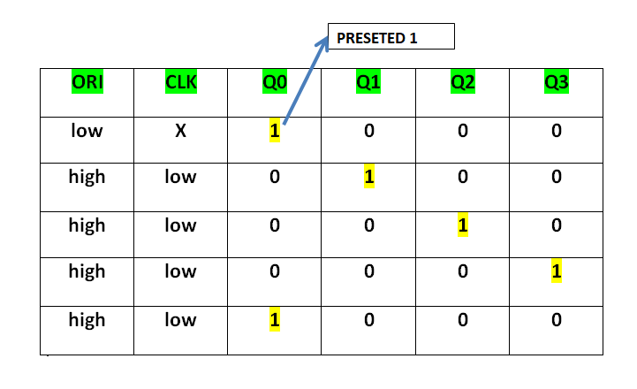

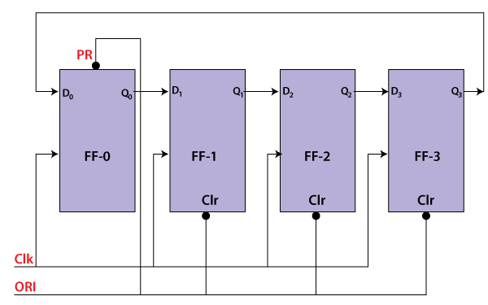

7 th pin Ground and 14 pin Ground

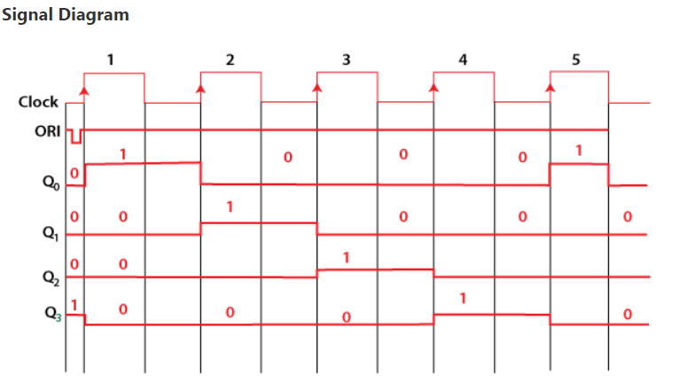

D FLIPFLOP IC 7474

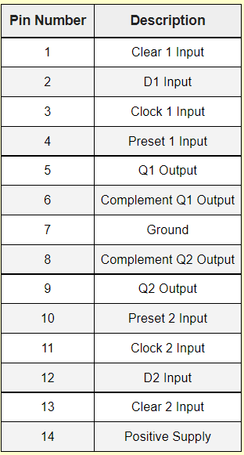 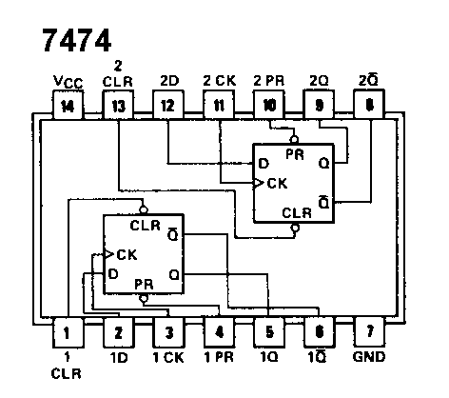

#### **Advantages / Disadvantages of Ring Counter**

**Advantages**

* It doesn’t need a decoder (i.e. It is a self decoding circuit)
* It can be can be implemented using JK and D flip-flops.

**Disadvantages**

* In ring counter, only 4 of the 15 states are being utilized.

Johnson Counter

Johnson counter also known as creeping counter, is an example of synchronous counter.

In Johnson counter, the complemented output of last flip flop is connected to input of first flip flop and to implement n-bit Johnson counter we require n flip-flop.

It is one of the most important type of shift register counter. It is formed by the feedback of the output to its own input.

Johnson counter is a ring with an inversion. Another name of Johnson counter are: creeping counter, twisted ring counter, walking counter, mobile counter and switch tail counter.

The 4-bit Johnson counter contains 4 D flip-flops and it counts 8 no.of cycles. The inverted output of the last flip-flop is fed back as input to the first flip-flop.

* From the figure, ABCD is the outputs of the flip-flop in the 4-bit pattern.
* The input value of ‘D’ is the inverted output of the last flip-flop.
* The ‘CLK’ is used to count the states or cycles of the counter, which is in the closed-loop.
* The reset pin is used as an on/off switch.
* As the data will be rotating around a continuous closed loop, a counter can also be used to detect various patterns or values within the data.
* For example, when there is a clock pulse, the output pattern of the flip-flops would be 1000, 1100, 1110, 1111, 0111, 0011, 0001
* When there is no clock pulse, the output will be 0000.

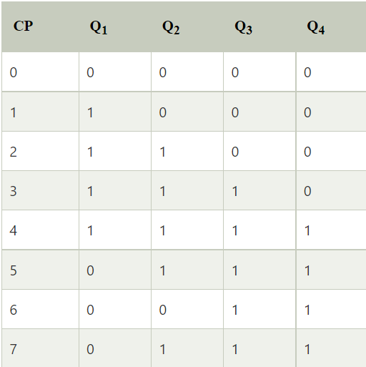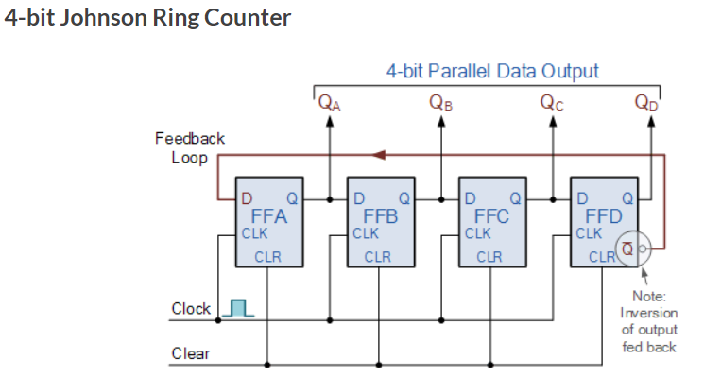

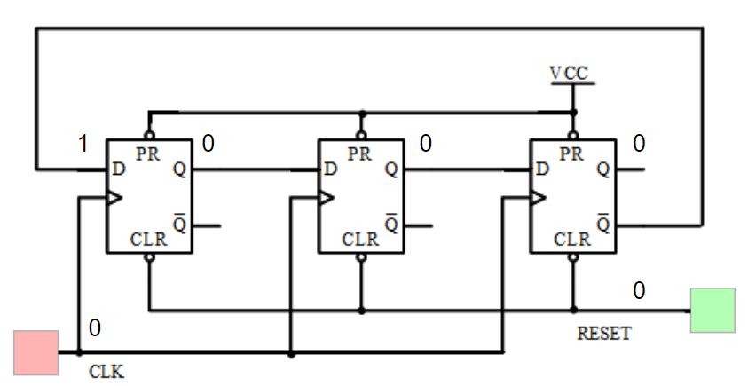

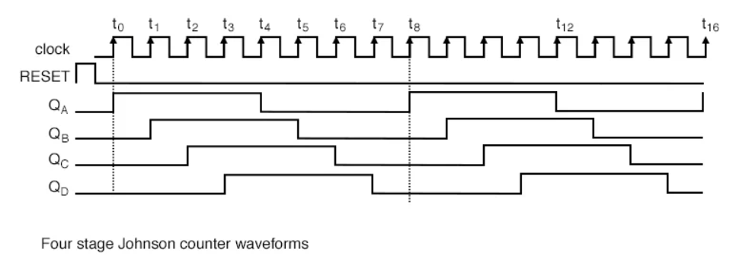

### **Advantages**

* The number of flip flops in the Johnson counter is equal to the number of flip flops in the ring counter, and the Johnson counter counts twice the number of states the ring counter can count.
* The Johnson counter can also be designed by using D or JK flip flop.
* The data is count in a continuous loop in the Johnson ring counter.
* The circuit of the Johnson counter is self-decoding.

### **Disadvantages**

* The Johnson counter is not able to count the states in a binary sequence.
* In the Johnson counter, the unutilized states are greater than the states being utilized.
* The number of flip flops is equal to one half of the number of timing signals.
* It is possible to design the Johnson counter for any number of timing sequences.